Remote education provision: information for parents

The remote curriculum: what is taught to pupils at home

What should my child expect from immediate remote education in the first day or two of pupils being sent home?
Home learning is placed on the school website weekly and can be found under the home learning tab. It is organised by class and then in some case year groups (This could be for maths where years group expectations may be different to whole class work.)
This week is set weekly and matches the work that the children have been completing in school, so it will not matter which day you start at – it will follow the work your child did yesterday.
In some cases, the work will link to our remote learning platforms or our online programmes, you will need to use your child’s diary to access these as this is where the passwords are kept.

Following the first few days of remote education, will my child be taught broadly the same curriculum as they would if they were in school?
We teach the same curriculum remotely as we do in school wherever possible and appropriate. However, we have needed to make some adaptations in some subjects. For example, we may have a slightly amend plan for some science work- where we feel families may not have equipment to hand, in this case we will try to find the best recorded lesson we can to show the experiment in action. We also feel that some of our music planning will be more than most families can offer so again we may offer a substitute lesson focusing on music appreciation rather that expecting families to have access to a variety of instruments at home.
PE at home will be different as we are aware of the limits on space and equipment families will have while undertaking isolation, but we will always offer an alternative.

Remote teaching and study time each day

How long can I expect work set by the school to take my child each day?
We expect that remote education (including remote teaching and independent work) will take pupils broadly the following number of hours each day:
Pupils in Reception and Key Stage 1  ( Class One ) | Will have 3 hours of planned provision each day
Key Stage 2  ( Class Two and Class Three) | Will have 4 hours of planned provision each day

Accessing remote education

How will my child access any online remote education you are providing?
Access to the planning and much of our resourcing is made directly through the School Website. http://www.kehellandschool.co.uk/
The tabs on the front page will take you directly to the Remote Learning page:
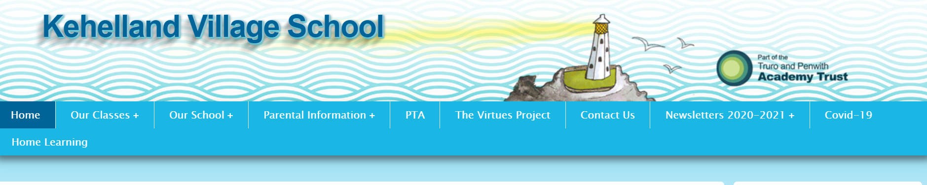
Pupils also have work set via Purple Mash and Seesaw. Logins can be found in your child’s reading diary, or by contacting the school.

If my child does not have digital or online access at home, how will you support them to access remote education?
We recognise that some pupils may not have suitable online access at home. We take the following approaches to support those pupils to access remote education:
When a family indicates that they do not have internet access we are able to provide access to planned learning via a full paper pack. This can be collected or posted when necessary. Paper copes can be returned to school for marking and feedback, or where possible sent to us via the seesaw app, using mobile data.
Where there is limited access to an internet connected device we have a limited number of laptops we can lend to families. Please contact the school if this would support your family.
Where internet speed is an issue we are able to provide additional connectivity and again this can be arranged by contacting the school directly.

How will my child be taught remotely?
We use a combination of the following approaches to teach pupils remotely:
Engagement and feedback
We use the same approaches to remote learning across the school.
All classes will have daily catch-up live sessions with a teacher, where they can ask for support with the learning for the day and where the teacher will give tips for getting the most of the planning and to support having shared expectations for the work produced. This session is the chance for the children to talk to the teacher and for the teacher to give supportive feedback to the class or individuals.
Our planning will be supported by:
- recorded teaching (e.g. Oak National Academy lessons, video/audio recordings made by teachers and TAs)
- printed paper packs produced by teachers (e.g. workbooks, worksheets)
- textbooks and reading books pupils have at home
- commercially available websites supporting the teaching of specific subjects or areas, including video clips or sequences.

What are your expectations for my child’s engagement and the support that we as parents and carers should provide at home?
We expect all families to engage in the planned remote learning on offer from the school. We would like to see families support learning through supporting taught session as well as through the provision of a learning space, in which the children can undertake some independent learning such as watching the recorded lessons.
We are happy to receive learning that is additional to the school planned learning, we have found that as parents you are really creative in the ways you supplement the children’s learning. Please do send in photos of the activities you undertake in addition to our planned sessions.

How will you check whether my child is engaging with their work and how will I be informed if there are concerns?
We are able to see the notifications on our Seesaw classroom app instantly and will try our best to respond quickly and provide feedback on the work.
Where we do not see work added to the child journal we will be in touch by phone to make sure that the family is well and to discuss how we can support you all.
We also undertake weekly welfare calls to all families we are not seeing at school, here you can let us know what aspects of the work you are struggling with and where it is too easy! This will help us to get the right balance for the children in our next week’s planning.
You can also request resources to support home learning in these conversations.

How will you assess my child’s work and progress?
Feedback can take many forms and may not always mean extensive written comments for individual children. Our approach to feeding back on pupil work is as follows:
Much of the work posted on seesaw will receive individual feedback with may be a positive comment or a specific element for improvement, please take the time to undertake and advice given with your child, then feel free to repost the corrections.

Some of the work is a formal test – such as the weekly popcorn maths tests. Other activities such as Kahoot tests are planned as a way or recalling known facts.

We use all the information form all your children work to help us understand the progress they are making and what specific things me need to add into the planning for groups or individuals.

If you feel the feedback is not supporting your child’s progress then please do contact the class teacher via the seesaw app.

Additional support for pupils with particular needs

How will you work with me to help my child who needs additional support from adults at home to access remote education?
We recognise that some pupils, for example some pupils with special educational needs and disabilities (SEND), may not be able to access remote education without support from adults at home. We acknowledge the difficulties this may place on families, and we will work with parents and carers to support those pupils in the following ways:
Where pupils are working towards EHCP targets we will draw these into a bespoke plan for the child that can be delivered remotely or when they access the onsite provision.
Pupils who receive additional support ins school will have individual materials sent to them to enable this important intervention work to continue while they are learning remotely.
Class teachers will support families to identify the most important aspects of the class planning for individual pupils to follow and will give focused feedback based on the ADPR targets.

Remote education for self-isolating pupils
Where individual pupils need to self-isolate but the majority of their peer group remains in school, how remote education is provided will likely differ from the approach for whole groups. This is due to the challenges of teaching pupils both at home and in school.

If my child is not in school because they are self-isolating, how will their remote education differ from the approaches described above?

